The Future of Engineering in Biomedicine

Student:
Professor:
Course:
Date:

The Future of Engineering in Biomedicine
Biomedical Engineering is a medical discipline with growing importance in society. Engineering plays a vital role in the biomedical field. It involves designing medical equipment and devices such as diagnostic machines, artificial organs, artificial equipment used in repairing body parts, and installing, repairing, or maintaining this medical equipment. This paper reflects on the future of engineering in biomedicine with regards to diagnostics methods and procedures.
Over the past years, there have been major expansions in biomedical engineering due to many factors. Some of these factors include the advancement of scientific and technological fields of cell biology and molecular biology. There is also increasing recognition of using interdisciplinary approaches to solve biomedical issues that require sophisticated engineering related solutions. Another reason why there has been an expansion of biomedical engineering is the need to cope with ever-increasing biomedical healthcare-related needs and associated demands and costs now that we have more aging populations (Hu, H 2020).
In approximately 10 to 20 years, there will be more sophisticated biomedical devices that are intended to revolutionize diagnostics methods and treatment procedures of complex medical conditions ranging from osteoarthritis to Alzheimer's.
With advancing technology and engineering tools, it is possible to achieve sophisticated biomedical equipment that will ease the diagnosis and treatment of complex medical conditions. The use of molecular imaging with optical technology and Magnetic Resonance Spectroscopic Imaging will make it easy to visualize smaller molecules in the living body and keep records of every dynamic progress of cellular and organic mechanism of a body (Hu, H.,2020). It will also make it possible to detect cancer cells at their earliest stages and eliminate them before advancing without the need for surgical procedures or exposure to radiotherapies. Molecular imaging will involve the use of a combination of optical technology with Magnetic Resonance Spectroscopic Imaging, which reduces exposure to radiations and frequent surgeries (Rahman, M., 2018).
Molecular imaging will be expected to have a significant effect on the diagnosis of complex diseases and in viewing how the diseases respond to therapy, particularly in the field of oncology. Molecular imaging will be some sought of a combination of diagnostic and therapeutic procedures. There are very high expectations that biomedical engineers will be able to visualize the disease site in 2D as well as in 3D.Nanotechnolgy will play a huge role in this area especially in 3D molecular imaging, one will be able to visualize a living body internal organs in 3D and be able to identify the site of the disease, fracture, complication or any foreign substance. This will in turn eliminate misdiagnosis and also help perform accurate surgeries with no subsequent complications (Rahman, M., 2018). Development of nanoparticles with therapeutic and with specific antigen-antibody particles will create a positive impact especially in strengthening the immune system since with this technique, you can manipulate atoms or molecules of an individual (Bulte, J. W. 2017).
Biomedical Engineering contributes to more than 70% of clinical practices that mostly involve instrumentation for diagnosis and therapy. In the next ten years or more, there will be the need to advance miniaturization, which will, in turn, advance manufacture of extremely small electronics and optical devices (Zare et al. 2019). This advancement in miniaturization will push the development of a high degree of complexity in imagining and virtual surgeries. The presence of very small optical devices will make it easy to perform molecular imaging. Advanced optical technology will make it possible for light from substances within the body to be imaged using tomography, which allows imaging of smaller molecular elements without exposing the body to dangerous rays and magnetic waves (Zare et al. 2019).
The mechanism of metastasis and growth of the cancer cell is expected to be explained through molecular imaging. Magnetic Resonance Spectroscopic imaging, combined with optical technology, will replace the use of conventional Magnetic resonance imaging (MRI). Engineering will also create even more positive impacts in the biomedical field by incorporating molecular-level information into complex modules. It will involve fusing various imaging methods, which will make it possible to detect every small dynamic processes occurring within the living body. The result will revolutionize diagnostics methods and treatment procedures of complex medical conditions ranging from osteoarthritis to Alzheimer's (Jiang et al. 2019). Early detections of onsets of diseases will be possible, especially cancer cells.
Though there has been an improvement in the early prediction of cancer cells before they advance, there are still some challenges. With the incorporation of molecular-level information into complex modules techniques, imaging of entire body processes and very small molecules will be recorded. Therefore, it will mean that whenever there is a foreign cell or unwanted growth of cells, no matter how small it is, it will be easily detected and perhaps eliminated and also every small progress of such cells will be tracked. Drugs that will be developed with the aid of molecular and cellular engineering will be expected to combat the progression of any form of a disease. For instance, an osteoarthritis condition will be eliminated without the need of having joint replacement surgery. This technique will also make it easy to view the distribution of drugs used for treatment throughout the body (Jiang et al. 2019).
In conclusion there are a lot of rapid changes in health care environment and with time advanced biomedical systems will be needed. Molecular imaging will not only apply in diagnostics or therapeutic processes but also in the pharmaceutical field (development of new drugs).the use of novel molecular imaging will play a huge role in the diagnosis and treatment of cancer cells and virtual surgeries. For cases of solid tumors or spread tumors, innovative molecular imaging will make it easy to locate and treat them without affecting the structures surrounding the tumor. It will also make it possible to administer and detect multiple radiotracers and reveal complex structures situated deep inside the body that others would have been difficult to decipher.

Reference
Hu, H. (2020). Recent Advances of Bio responsive Nano-Sized Contrast Agents for Ultra-High-Field Magnetic Resonance Imaging. Frontiers in Chemistry, 8, 203.
Jiang, J., Li, K., Kemerovo, S., O'Sullivan, J. A., & Tai, Y. C. (2019). Feasibility study of a point‐of‐care positron emission tomography system with interactive imaging capability. Medical physics, 46(4), 1798-1813.
Zare, E. N., Jamal din, R., Naserzadeh, P., Afjeh-Dana, E., Ashtari, B., Hosseinzadeh, M., ... & Makvandi, P. (2019). Metal-Based nanostructures/PLGA nanocomposites: antimicrobial activity, cytotoxicity, and their biomedical applications. ACS Applied Materials & Interfaces, 12(3), 3279-3300.

Rahman, M., & Watabe, H. (2018). Online molecular image repository and analysis system: a multicenter collaborative open-source infrastructure for molecular imaging research and application. Computers in biology and medicine, 96, 233-240.
Bulte, J. W., & Modo, M. M. (2017). Nanoparticles as a technology platform for biomedical imaging. In Design and Applications of Nanoparticles in Biomedical Imaging (pp. 1-7). Springer, Cham.

Appendix
Figure 1: The overview of clinical and science imagery needs

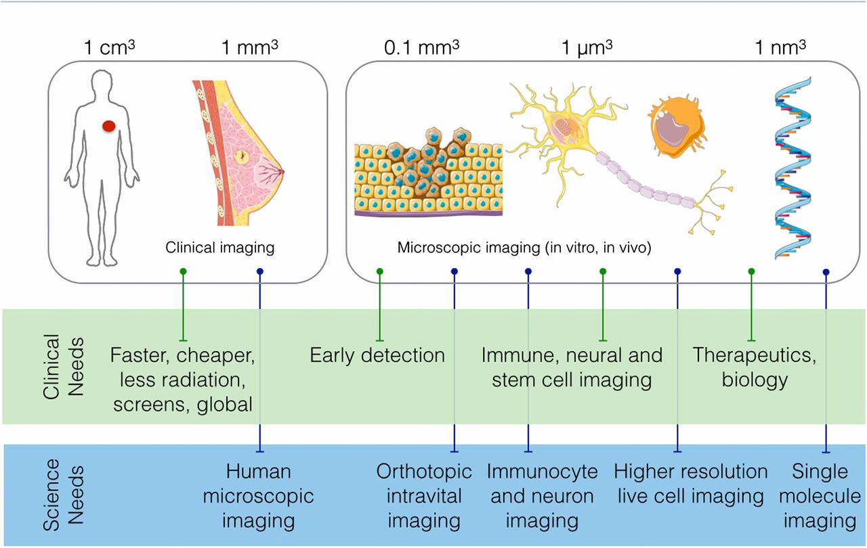
Source: https://www.pnas.org/content/112/47/14424

Figure 2: Flow chart of novel molecular imaging
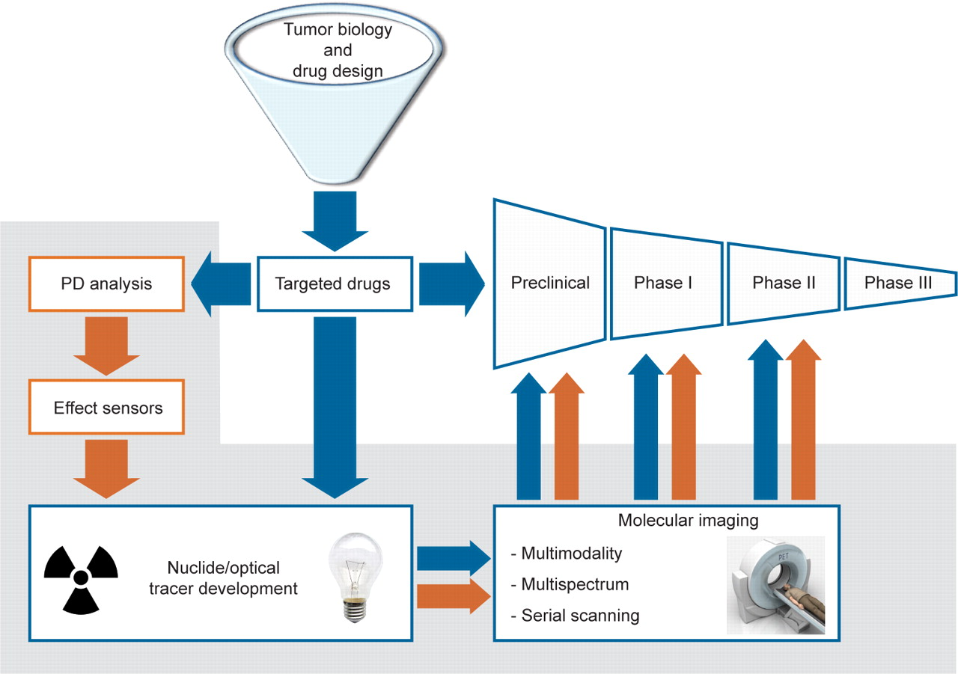
Source: https://cancerdiscovery.aacrjournals.org/content/1/1/25.figures-only

